## ED KIIRU

Mortgage R1:SP4:Story 6

Provide the URL to the task completed on R1 SP4 Story 6- **Design and Load the data in a Dimensional Model. Create at least one Type 2 SCD.**

[**https://3.basecamp.com/3945211/buckets/26719787/todos/7189059015#__recording_7585583493**](https://3.basecamp.com/3945211/buckets/26719787/todos/7189059015#__recording_7585583493)

**Created the datawarehouse database**

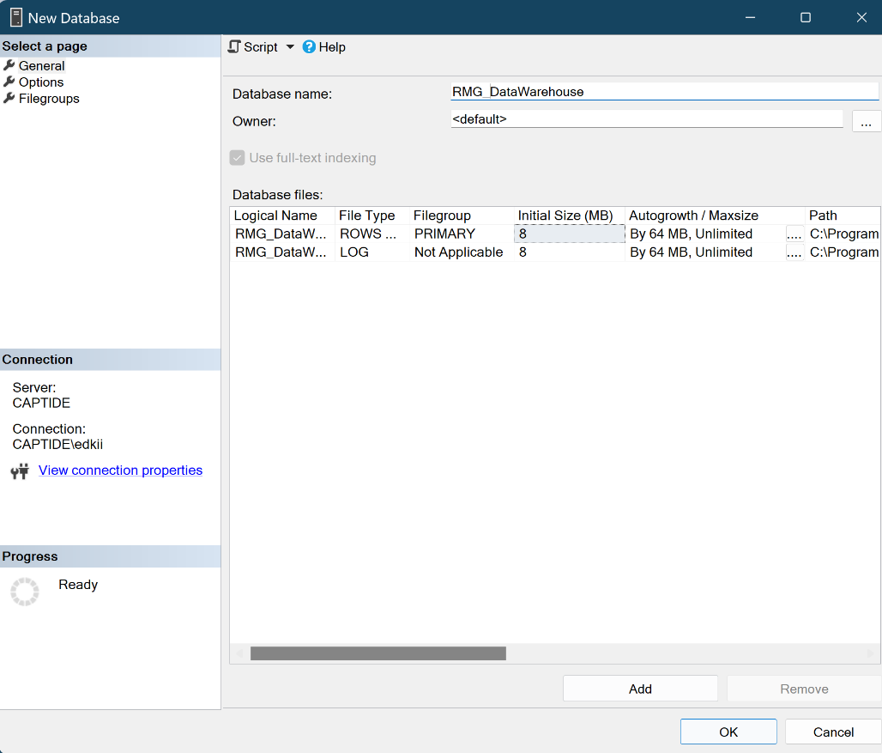

Created a Stored procedure that on executioncreates and insurts the dimention and fact tables

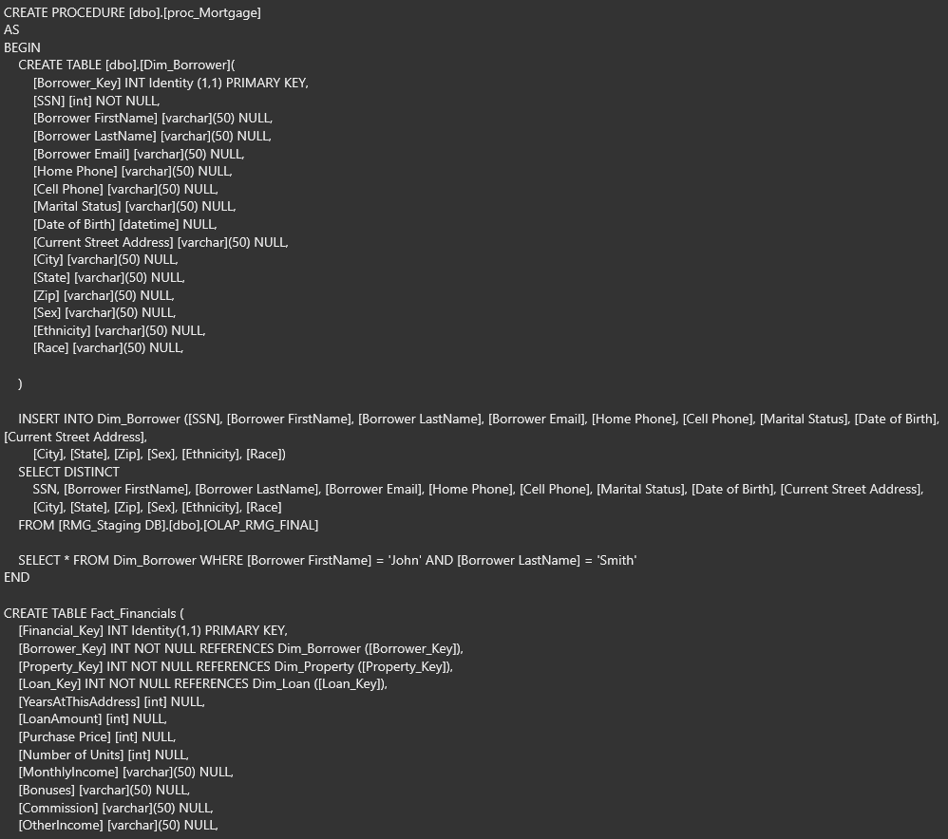

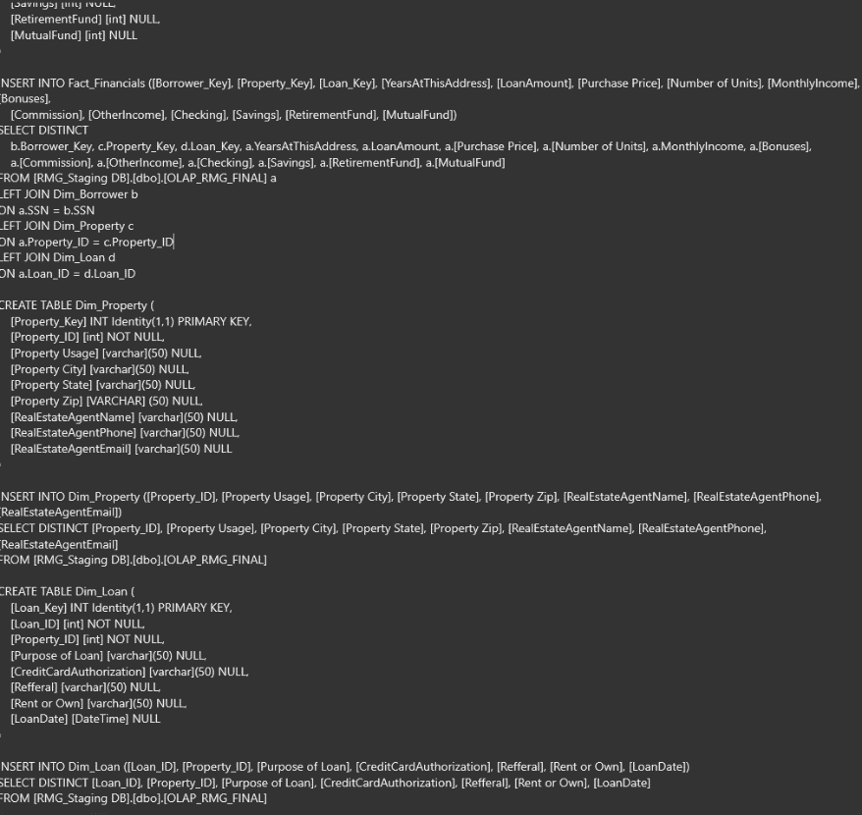

**Created a Database diagram**

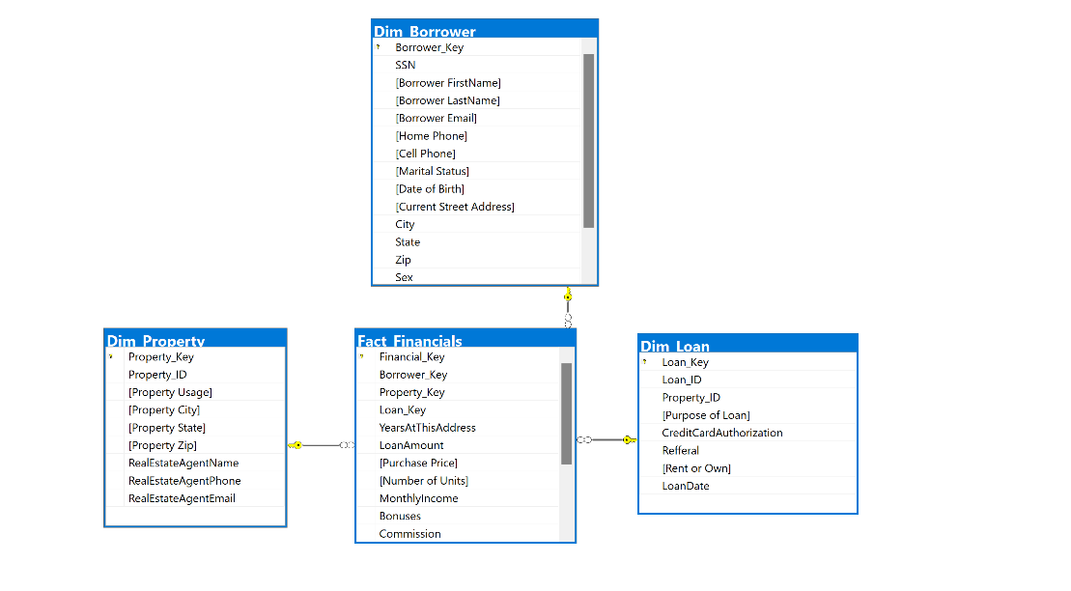

**Started bulding the Control flow with an execute task and the dataflow task**

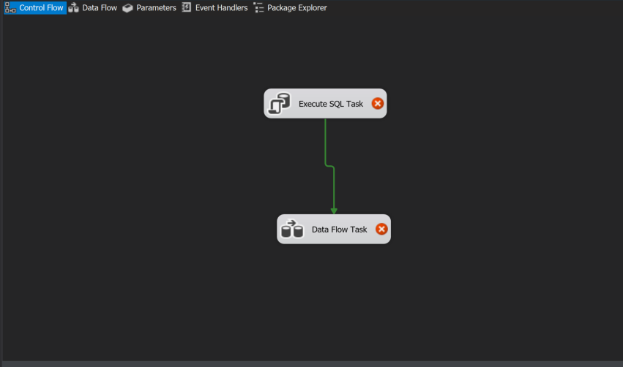

**Configured the source connection manager**

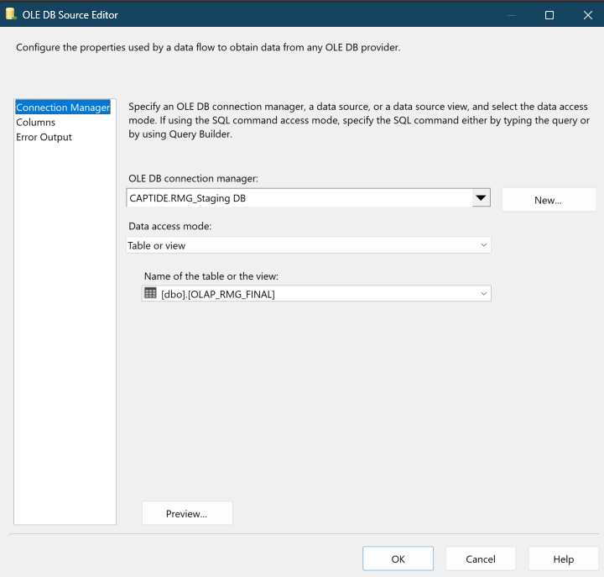

**Configured the Destination connection manager**

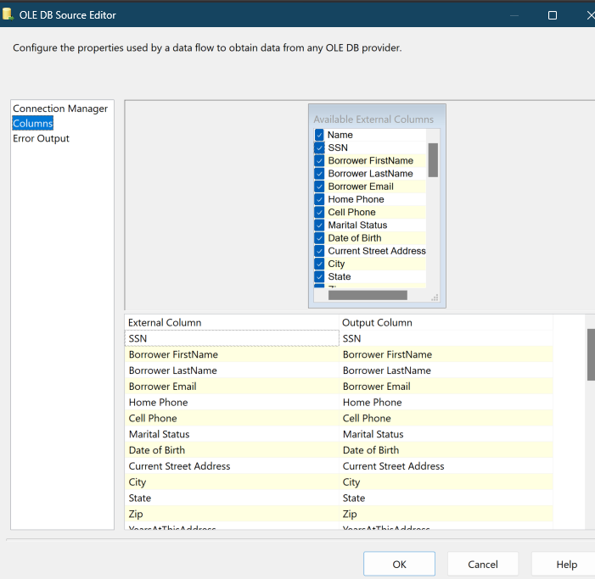

Added the Slow Changing Dimention Task

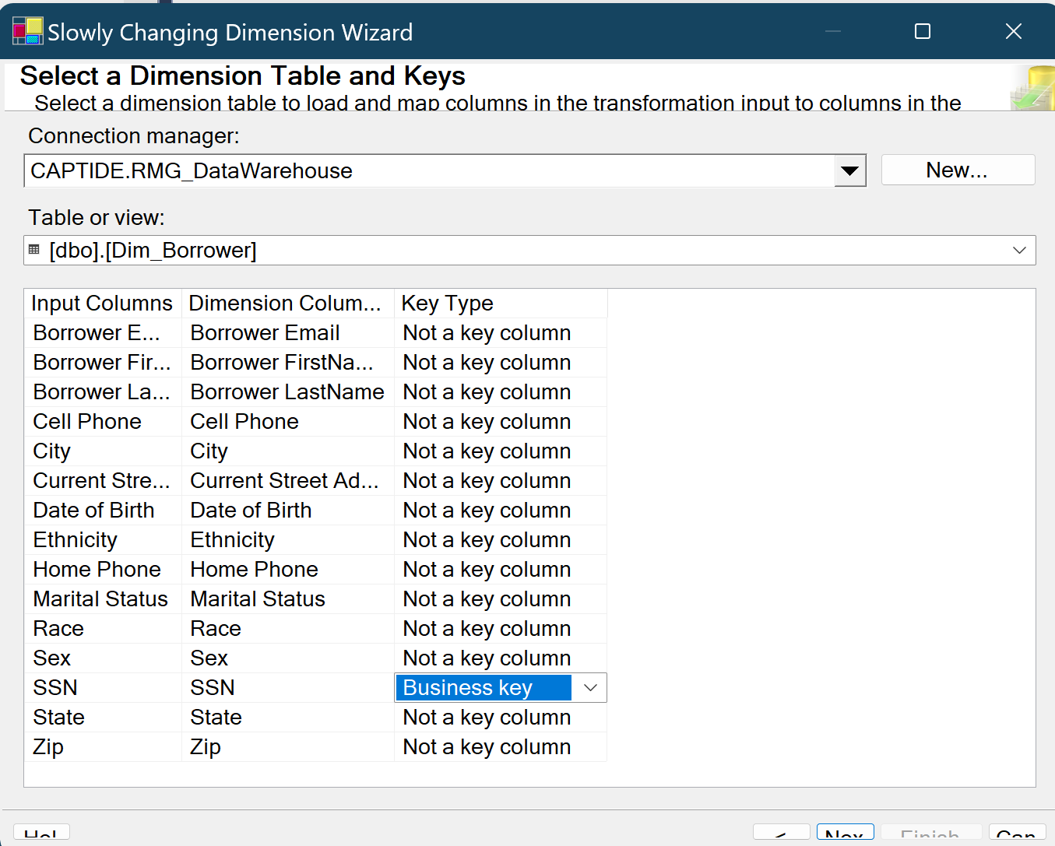

Configured SCD task through the wizard

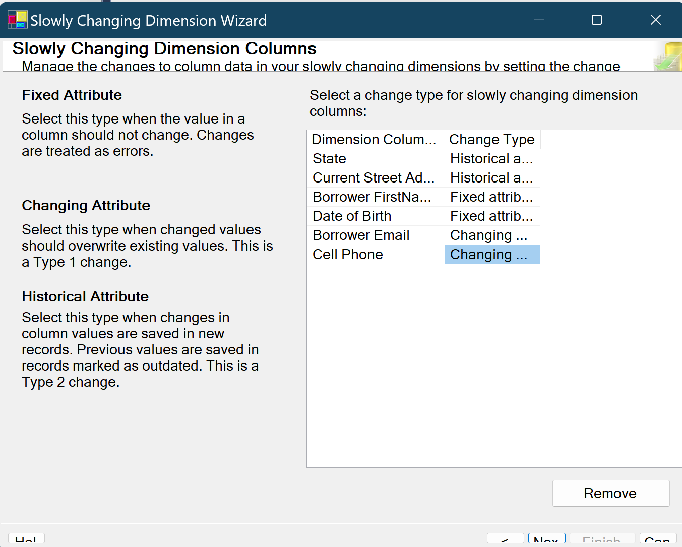

Set the Fixed and changing attributes

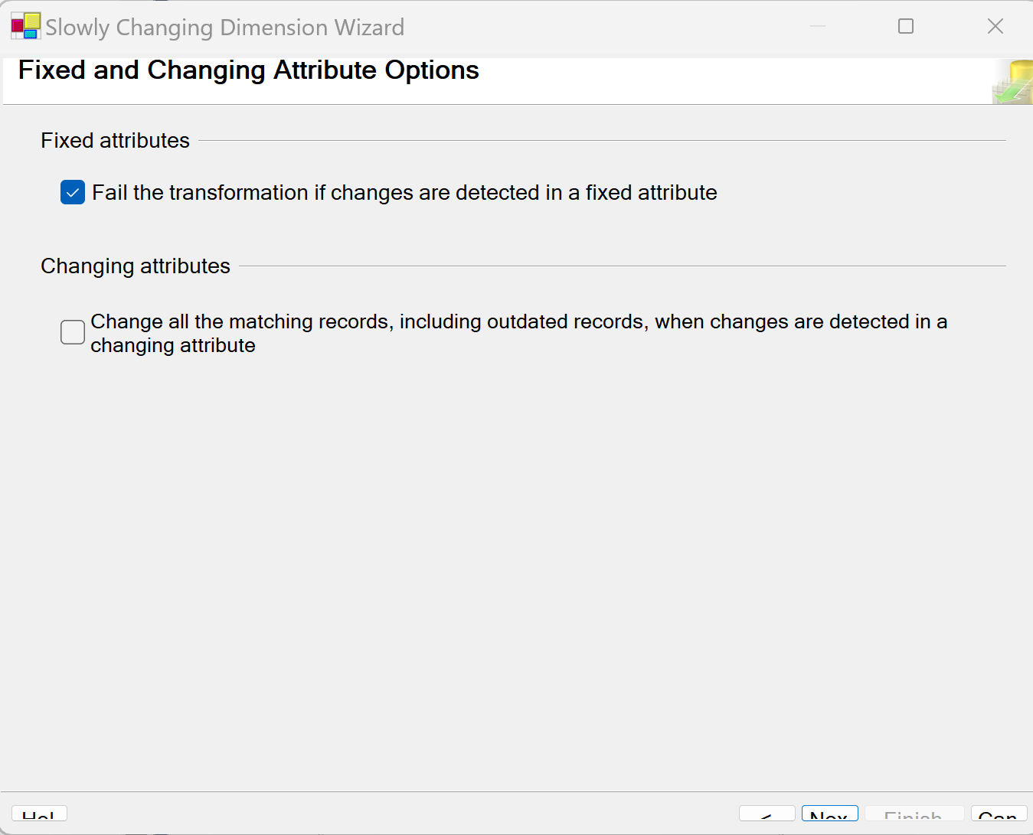

Added Historical attributes

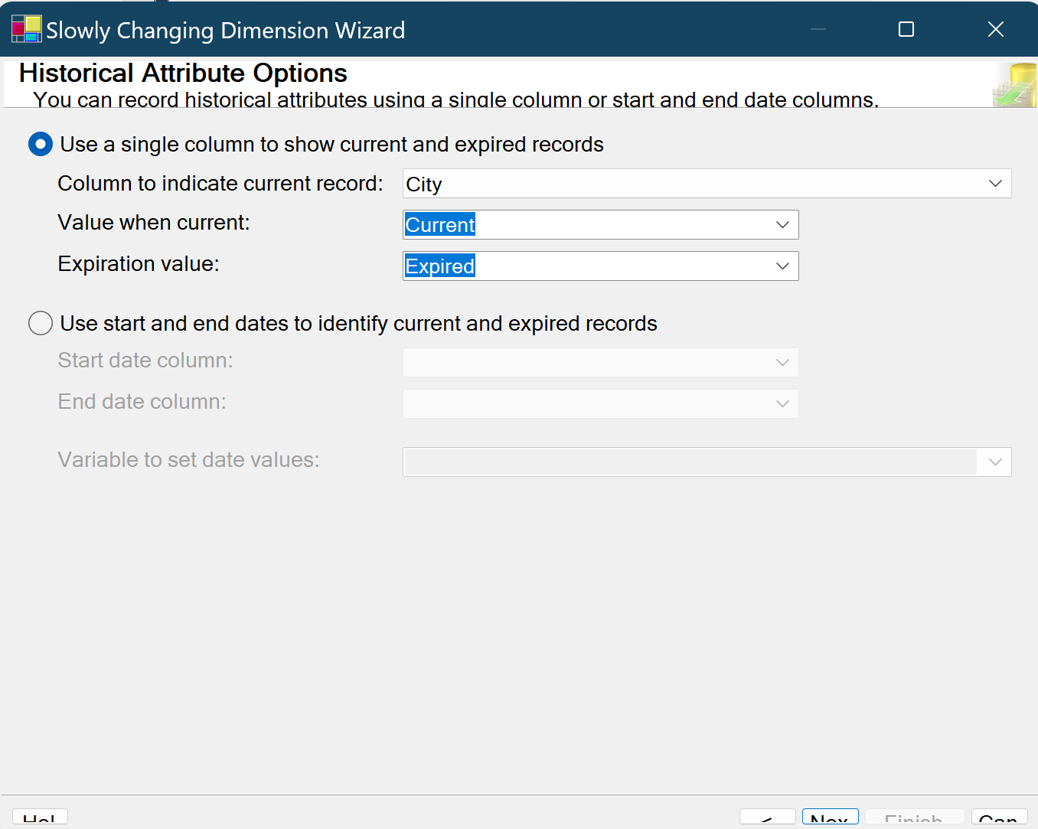

Finished the SCD setup

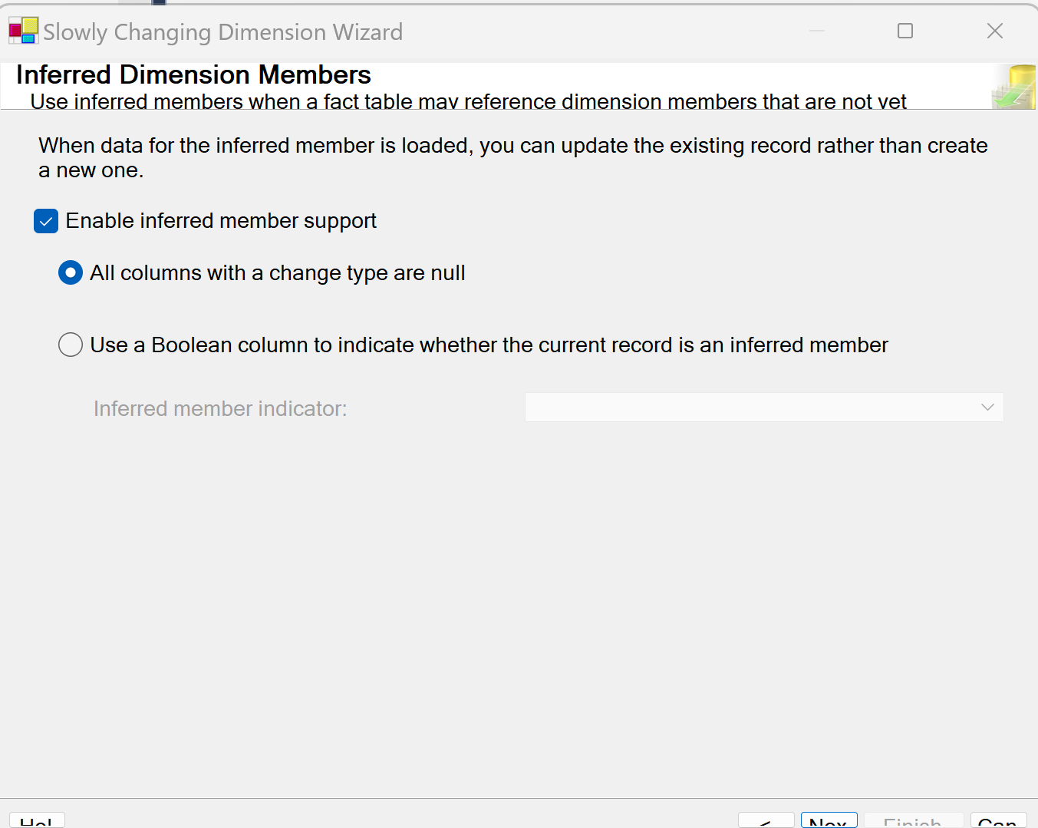

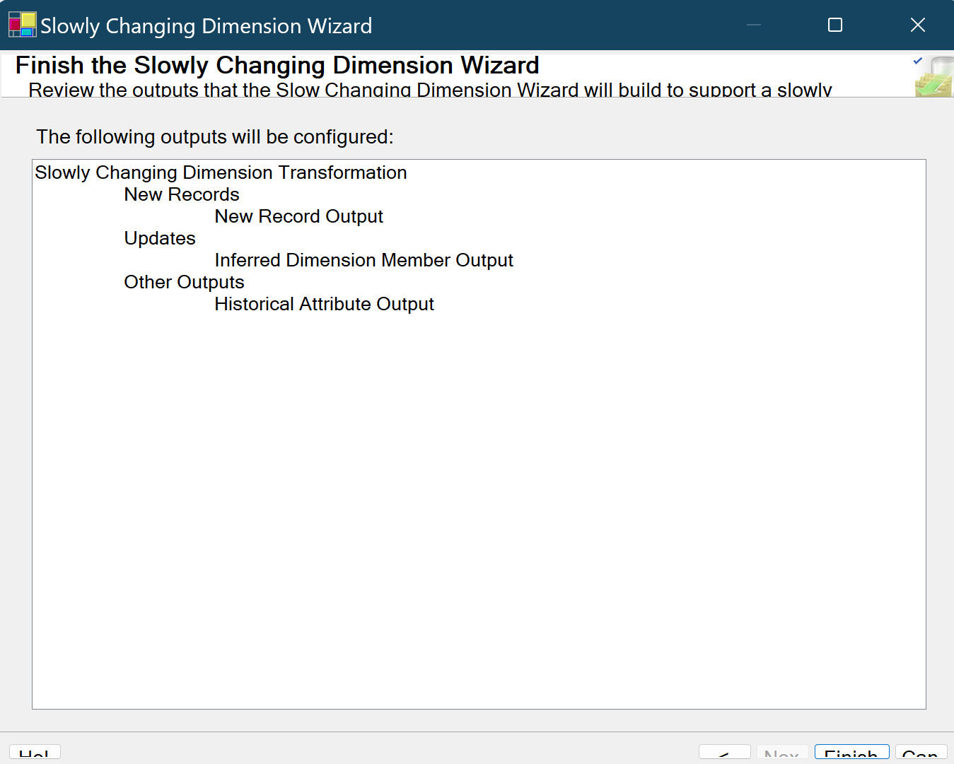

Data flow after setting up the SCD task

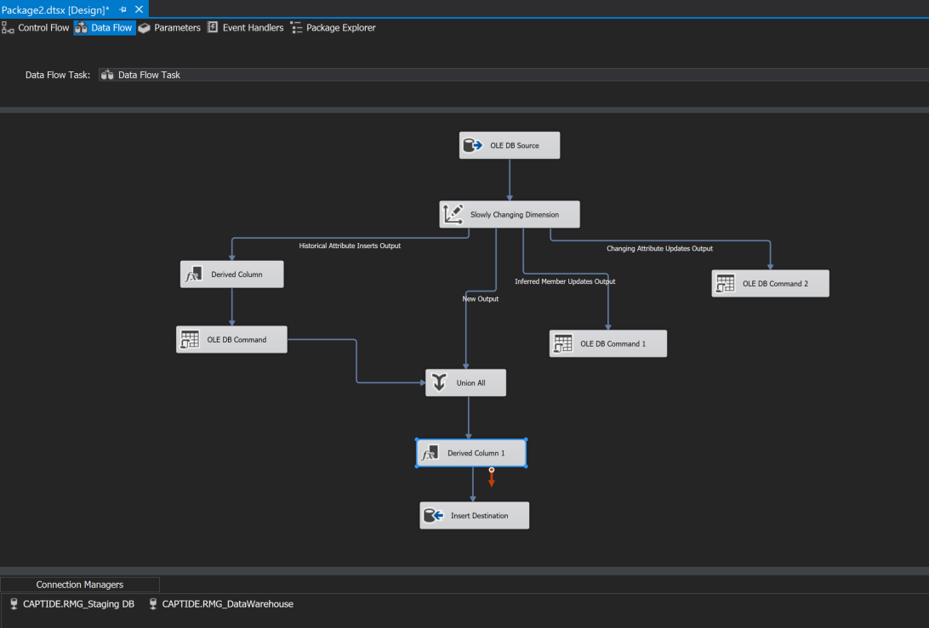

Execution went through Ok

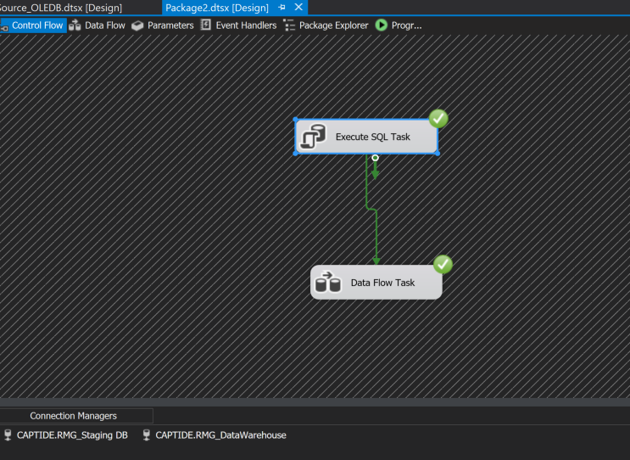

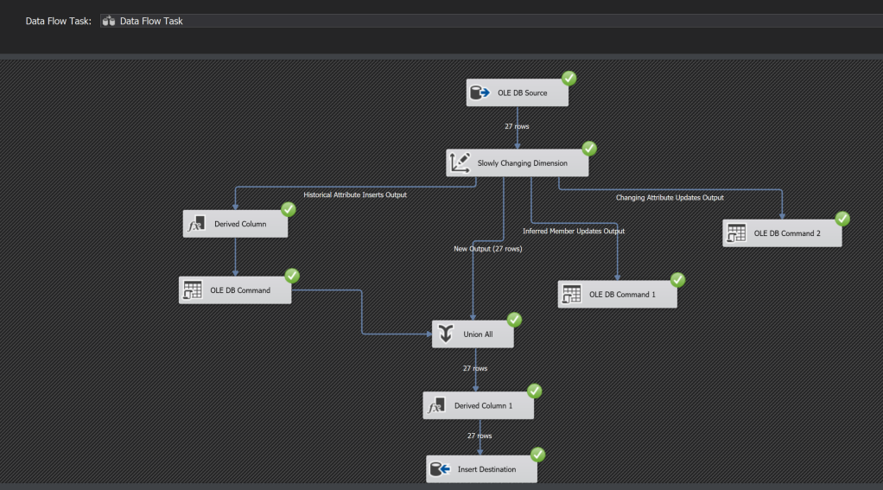

Made changes to the Borrower Firstname attribute

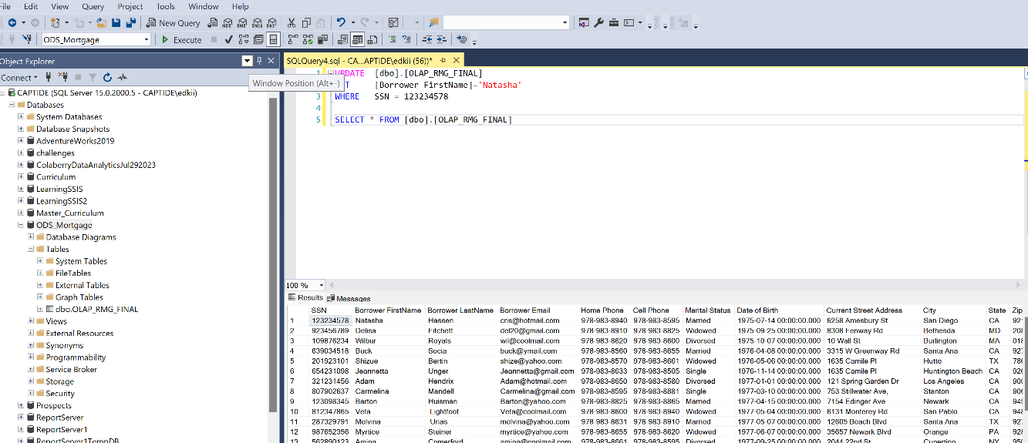

Executed, and noted the Changing attribute updates

Confirmed the Historical attribute insert

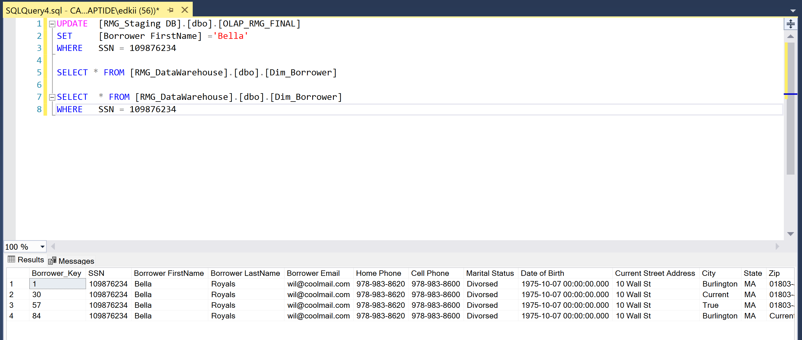

Made changes to the Loan table

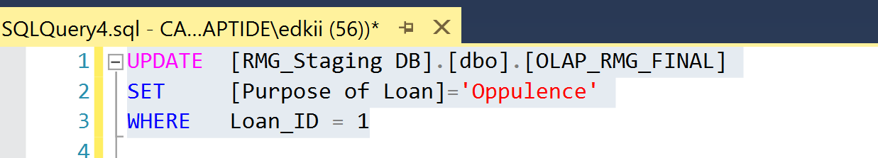

Noted the Historical Attribute inserts

Confirmed the historical attributes inserts

